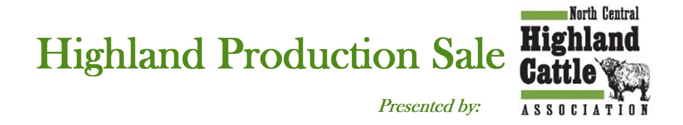March 13, 2021 – ONLINE ONLY SALE
* Online Sale through Integrity Livestock*

-ENTRY FORM-
DUE: February 15, 2021

I would like to enter the following: (Please indicate number of head)

_____ Cow/Calf Pairs _____ Open Heifers _____ Highland Sovereign Heifers

_____ Bred Cows _____ Bred Heifers _____ Bulls

_____ Steers _____ Embryos _____ Semen

Complete the enclosed form for each animal entered (make copies if necessary).
Forms, copies of registration papers, entry fees and photos should be submitted online at
www.HighlandSale.org

PHOTOS and VIDEOS are due no later than March 1, 2021. Failure to provide photos and/or videos on time may forfeit your entry slot and fee.

-CONSIGNOR-

Name: ______________________________________________________________________

Farm/Ranch: _________________________________________________________________

Complete address: ____________________________________________________________

Town/City: ________________________________ State: ________ Zip Code: ___________

Phone Number: _______________________________________________________________

Email Address: ________________________________________________________________

Make check payable to: _________________________________________________________

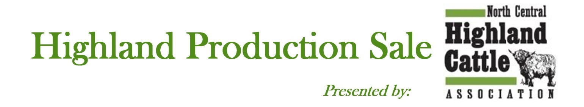

Please return all information, COMPLETED IN FULL and submit online at www.HighlandSale.org
(Please enter name and address as you want it to appear in the catalog. Also note if you want phone number and email address listed.)
Farm/Ranch Name: _________________________________________________________________________
Owner: ___________________________________________________________________________________
Address (Please use 911 address): ______________________________________________________________
City: __________________________________________ State: ___________ Zip Code: __________________
Phone: (Home) ___________________________ (Cell) ___________________ (Work) ____________________
(Fax) _________________________ Email: ________________________________________________
___________________________________________________________________

Animal Name: _______________________________________________________________
Birth Date: ___________________________ Reg. #__________________ Tattoo: ___________ Color:___________
___________________________________________________________________

Pedigree – Fill in or attach copy of Registration
(Must be completed if Registration is pending)

____________________________________
Sire: ______________________________
Reg #: __________________
____________________________________

____________________________________
Dam: ______________________________
Reg #: __________________
____________________________________
____________________________________________________
Breeding Information If selling with newborn calf *
AI’d to: __________________________________________ Calf Name: ________________________________
AI’d Date: ________________________________________ Birth Date: ___________________ Sex: _________
AI Reg #: _________________________________________ Tattoo: ______________________ BW: ________
Pasture Exp. To: ____________________Reg # __________ Sire: ______________________ Reg # __________
From: ______________To: ___________ Calf Reg # *: ____________
Examined Safe: _____________ to AI or Pasture Est. Due date: ______________

* Calves must be registered or have pending registration. If not, calves will be sold as unregistered.

Marketing Information – write a paragraph about your cattle for online and the sale catalog – THIS IS REQUIRED for entry.

_____________________________________________________________________________________________

_____________________________________________________________________________________________

_____________________________________________________________________________________________

_____________________________________________________________________________________________
2021 SALE AGREEMENT
(Consignment Sales)

Name of Sale: Highland Cattle Production Sale presented by NCHCA
Date: March 13, 2021

By participating in this consignment sale, I agree to abide by all rules regarding the sale sponsored by the North Central Highland Cattle Association. I understand that sale proceeds will be disbursed within a 60-day period after the sale.

I also understand that all consignments will be charged a uniform sales commission of 8% to cover shared expenses from all consignors for advertising, catalogs, sale facilities, etc. I agree that commission will be charged on any last bid received in the sale ring and it constitutes the basis for sale expense, which includes floor prices, pass outs, etc., and the seller will be charged 8% commission or 4% commission for buy backs, based on this number. I understand that entry fees ($50 per animal for NCHCA members, $80 for non-members) are not refundable.

I certify that I am the owner of the consigned cattle, and all statements, pedigrees, photos and video information provided is factual and in accordance with the guidelines of the American Highland Cattle Association.

I give the Highland Production Sale presented by North Central Highland Cattle Association committee permission to use my information and the images provided to promote my submissions as they best see fit.

I have read and will adhere to the following requirements. Registered animals must have a legible tattoo that corresponds with registration papers. All animals must have a USDA-APHIS approved ear tag linking to the farm of origin. All animals must have a negative BVD test. (This is a one-time test, so if your animal has been tested please note that results of that test is all we need.) The test should be the PI test. Females under 24 months must be vaccinated for Brucellosis or be tested Brucellosis free. All females over 24 months must be tested negative for Brucellosis. Pregnant animals must be confirmed in calf or listed as open on the health certificate. All entries must be poured with parasitical control within 10 days of buyer pick up (please be sure that your product contains appropriate measures for sucking lice) and date of treatment must be provided. All bulls born 15 months or older must pass a breeding soundness exam, performed by a licensed veterinarian. Any non-virgin bull will need to be Trichomoniasis Tested. All bull testing reports need to be complete and uploaded to HighlandSale.org by March 1, 2021, or your bull will be scratched from the sale and you will forfeit your entry fee. See the official health requirements outline at HighlandSale.org.

A write up of all vaccinations/calving records/vet care would be appreciated for new buyers. A minimum of this year’s vaccinations is encouraged. This is at consignor’s discretion, but the minimum is encouraged. Upon completion of the sale, any animals being transported out of the state of current residence must have a health paper completed for the animal at the seller’s cost.

Videos and all photos are due by March 1, 2021, or you may forfeit your entry with no entry refund.

Signed: _______________________________________________________________________
(not valid unless signed)

Print name: ____________________________________________________________________

Farm/Ranch: ___________________________________________________________________

Date: _________________________________________

PLEASE SIGN AND RETURN WITH ENTRY FORM BY February 15, 2021

